Assignment 1

Task 1: Creating and Renaming Files/Directories

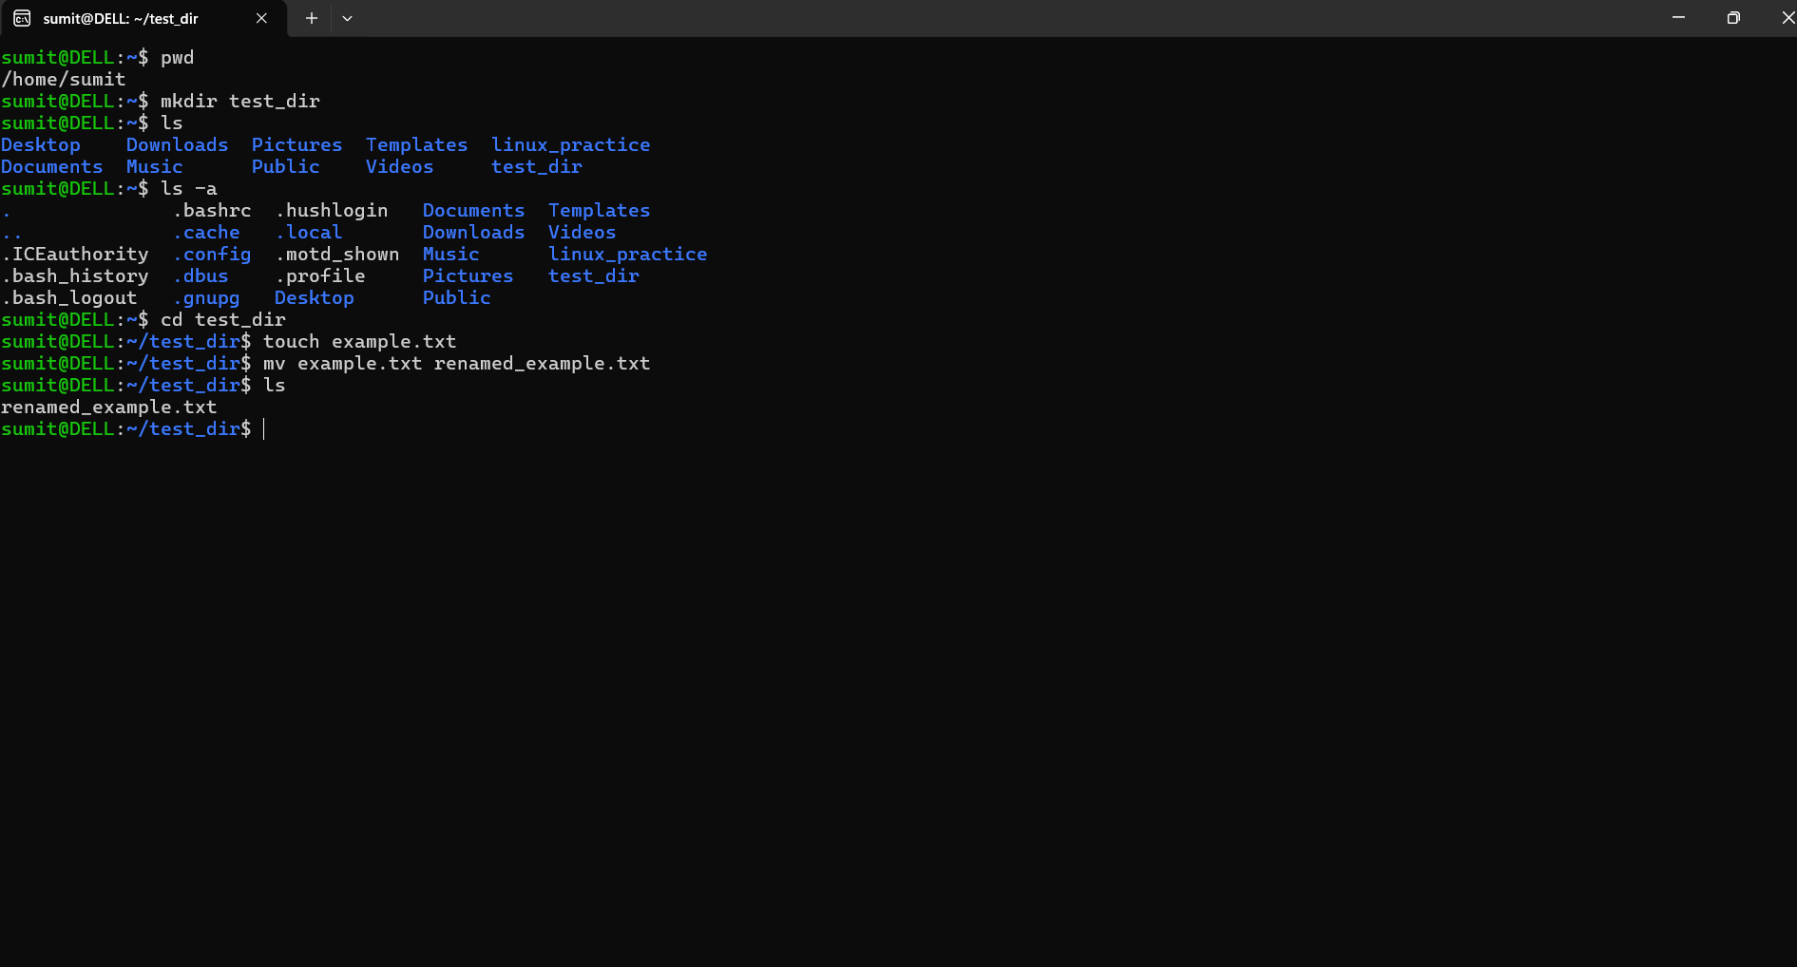

Commands used-
mkdir test_dir
cd test_dir
touch example.txt
mv example.txt renamed_example.txt
ls
Explanation
mkdir creates a new directory.
touch creates an empty file.
mv renames or moves files.
ls lists directory contents

Task 2: Viewing File Contents

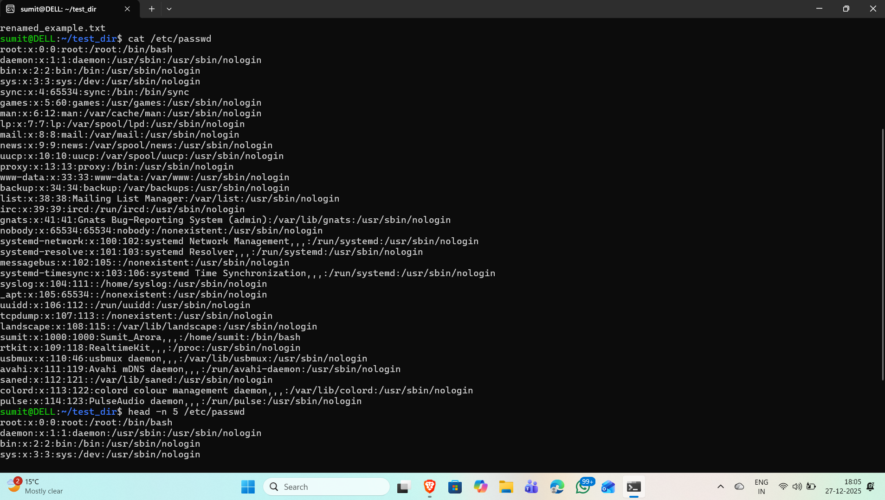Commands used-
cat /etc/passwd
head -n 5 /etc/passwd
tail -n 5 /etc/passwd

Explanation:
cat displays full file content.
head shows the first few lines.
tail shows the last few lines.

Task 3: Searching for Patterns

Commands used-
grep root /etc/passwd

Explanation:
grep root /etc/passwd

Task 4: Zipping and Unzipping Files

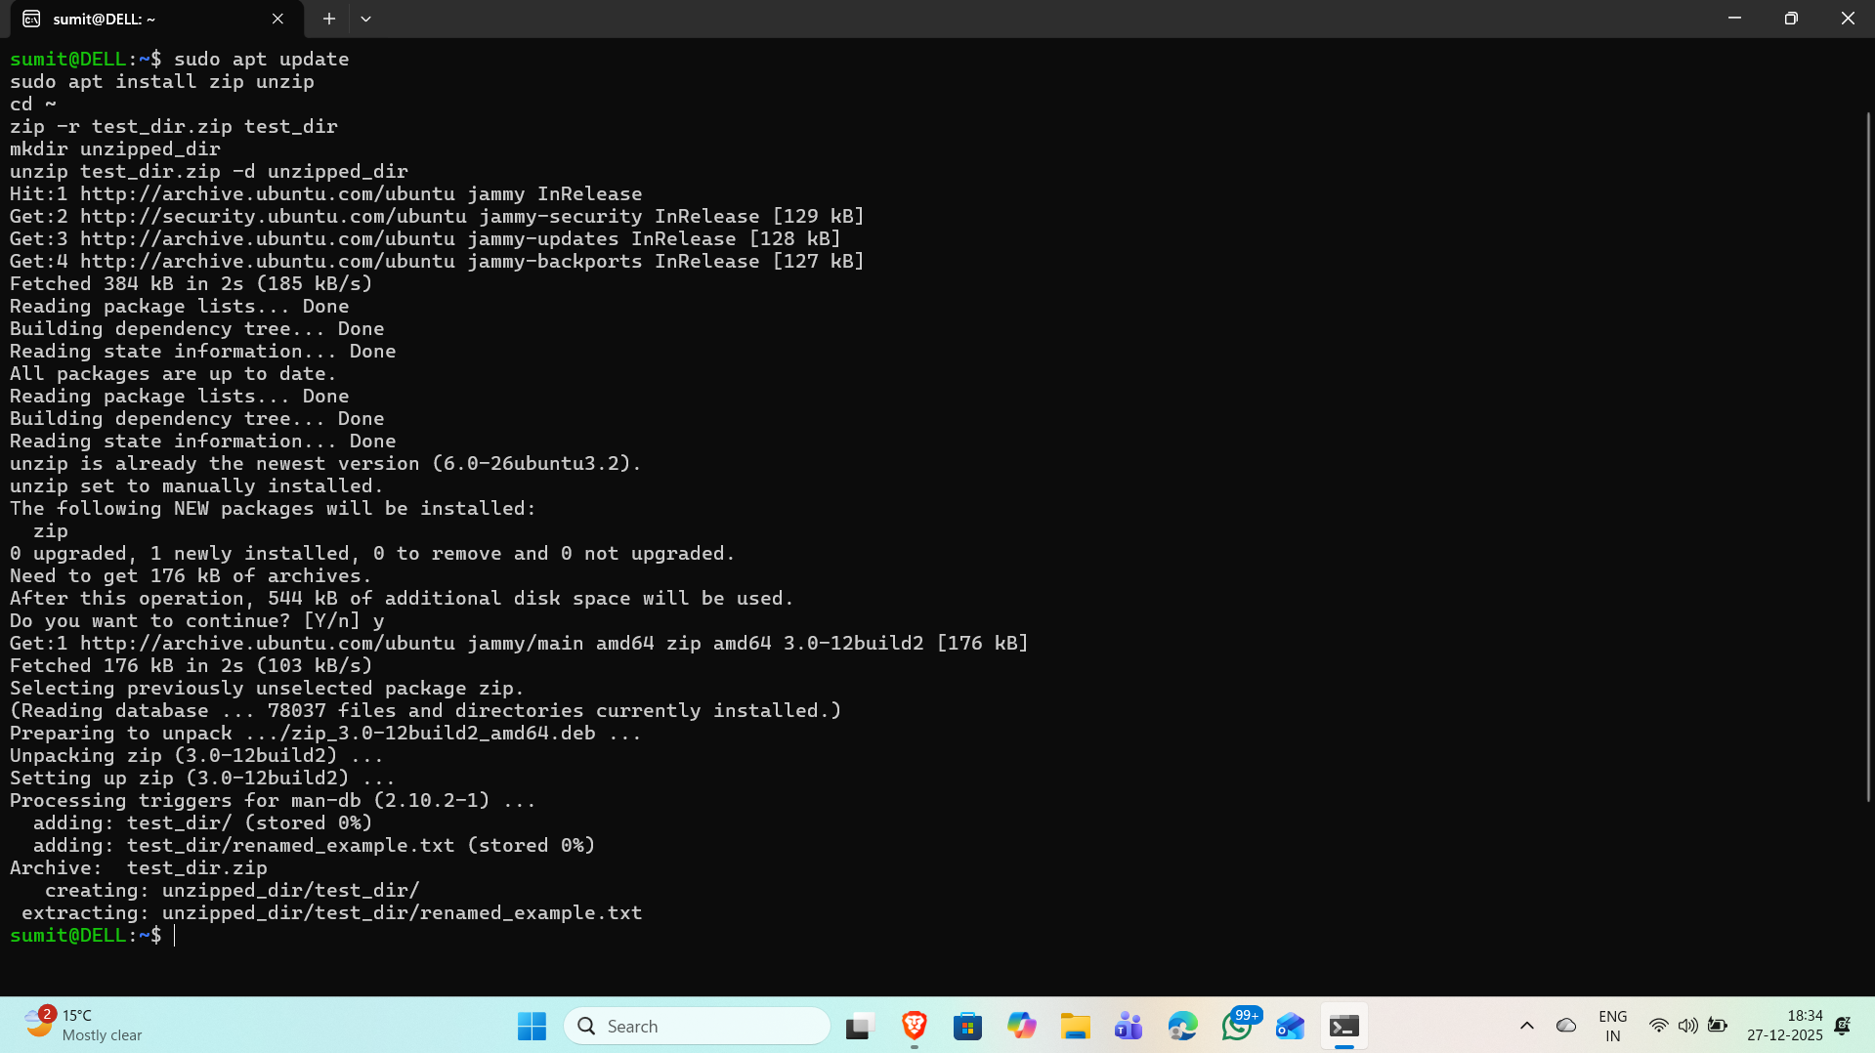
Commands used-
sudo apt install zip unzip
zip -r test_dir.zip test_dir
mkdir unzipped_dir
unzip test_dir.zip -d unzipped_dir

Explanation-
zip -r compresses a directory recursively.
unzip extracts files into a specified directory.

Task 5: Downloading Files

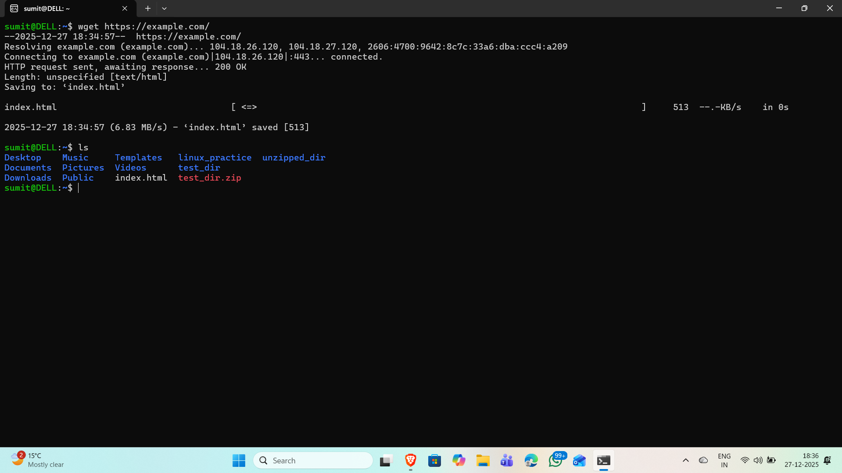Commands used-
wget https://example.com/Ex

Explanation:
wget downloads files from internet via terminal

Task 6: Changing File Permissions

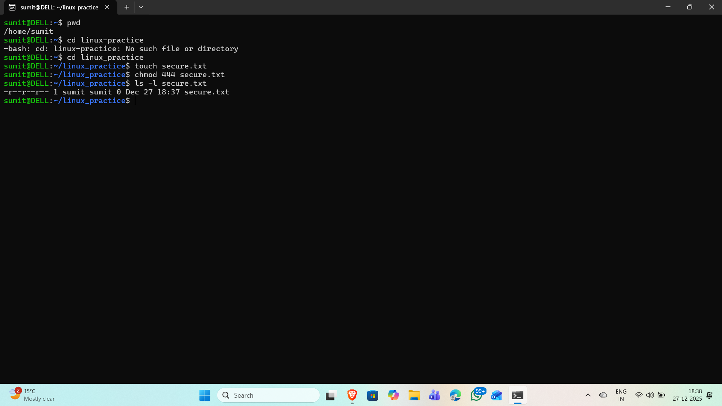

Commands used:
touch secure.txt
chmod 444 secure.txt
ls -l secure.txt

Explanation:
chmod 444 makes the file read-only for user, group, and others.
ls -l displays permission details.

Task 7: Environment Variables

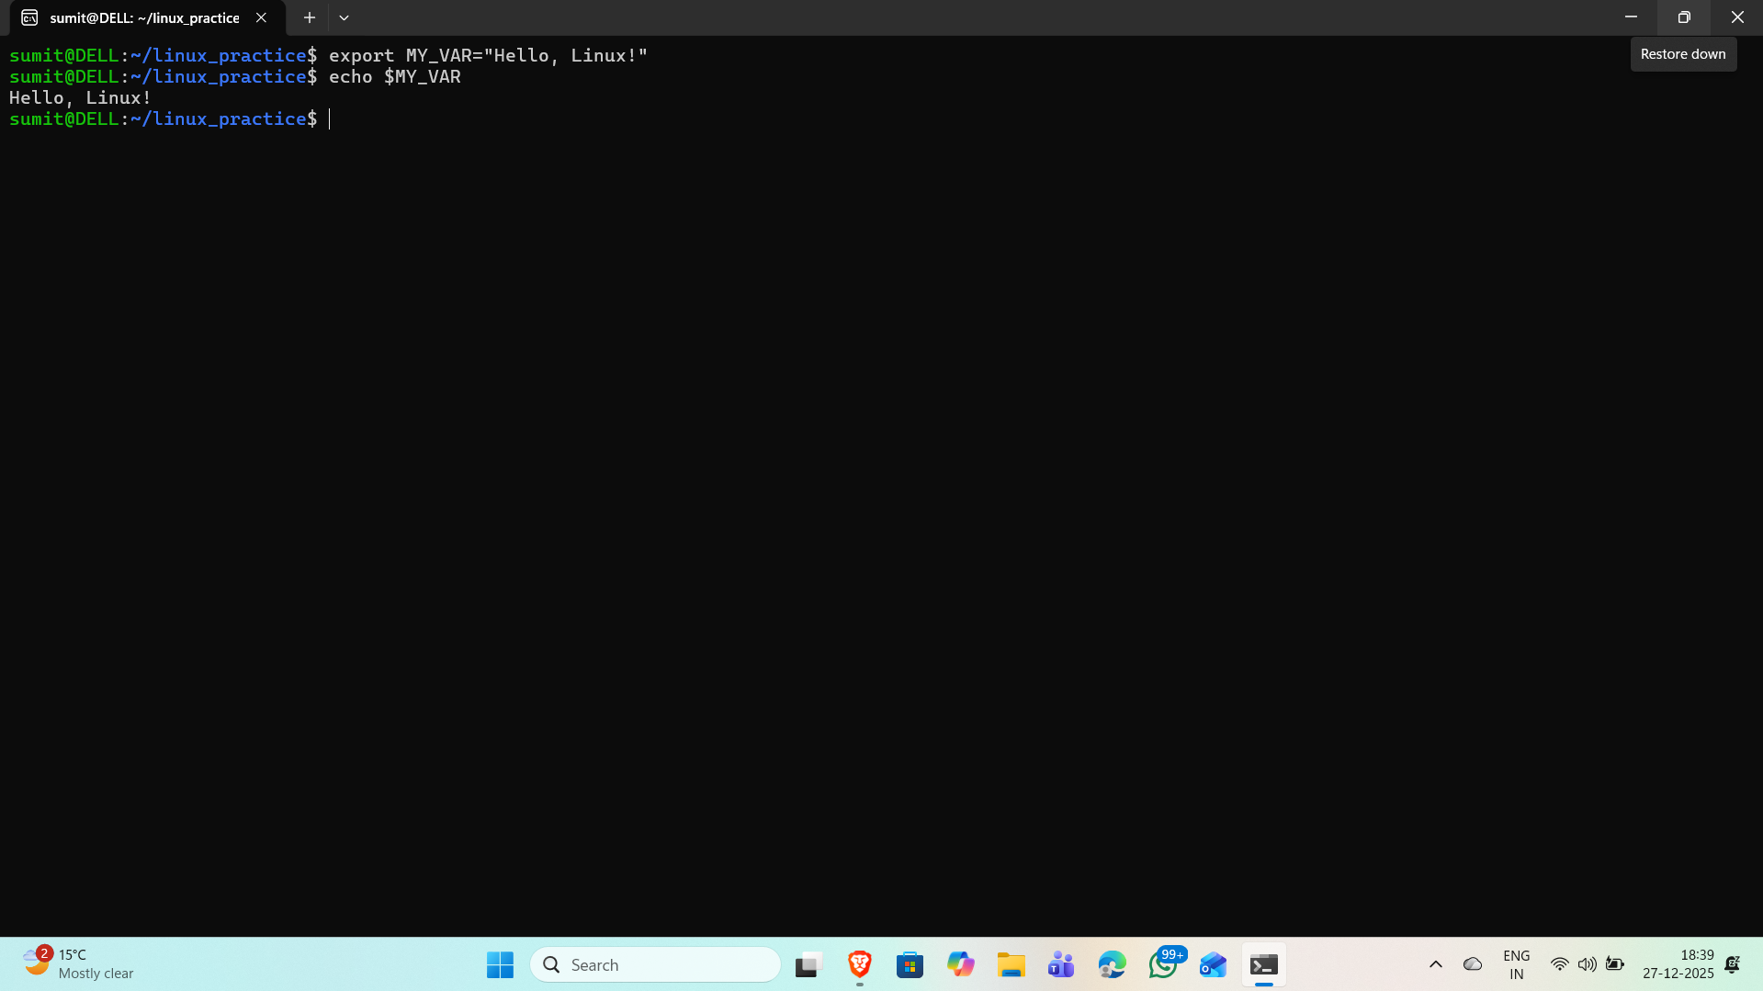
Commands used-
export MY_VAR="Hello, Linux!"
echo $MY_VAR

Explanation-
Export sets an environment variable,
Echo displays its value

